**REGex Software Services**

**Java Full Stack Development Program**

Registration I'd:  **IIPRSS1404**

Name: **Shanmukh Subhash Kumbhar**

Subject: Assignment **13** - # **Multi-threading**

Core Java 2021 **Core Java Session 13 Assignments**

1. Develop a Program to implement thread using Runnable interface.

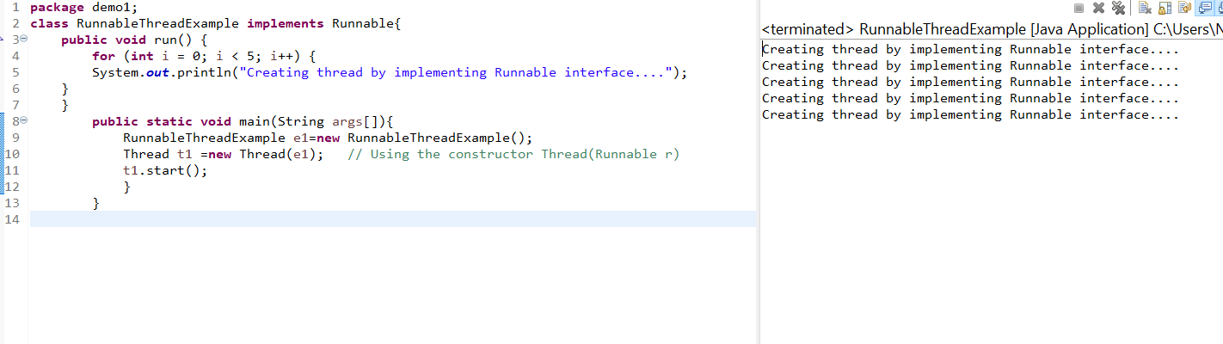

1. Develop a Program to implement thread using Thread class.

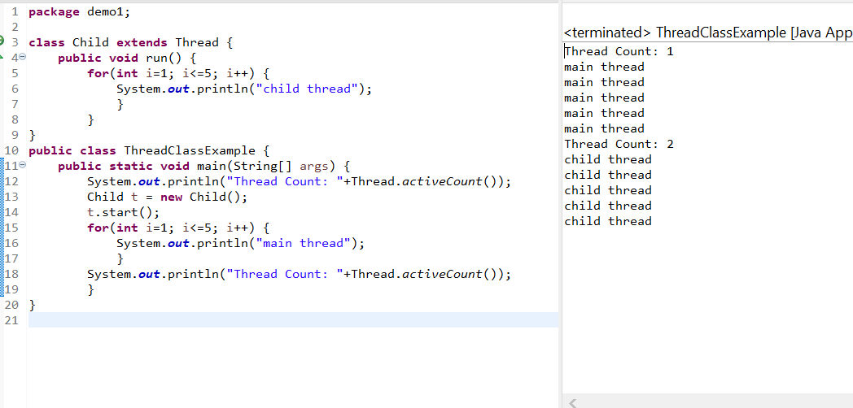

3. Develop a Program to get and set name of thread.

